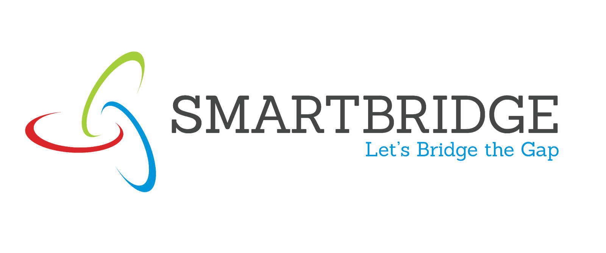
Business Question and Visualization Report

Date | 14 August 2026
Team ID
Project Name | Global AI Adoption in Education: A Comprehensive Global Performance Analysis
Maximum Marks

Business Questions and Visualisation
1. KPI DASHBOARD
This section provides a consolidated view of key AI adoption metrics through KPI cards. It displays four critical metrics: Average Daily AI Usage (32.82 minutes), Total AI Adoption Records (1,360), Average Rural AI Usage Percentage (21.60%), and Average Urban AI Usage Percentage (33.56%). These indicators act as a starting point for deeper analysis by summarizing complex data into simple numeric insights. Users can immediately assess the overall state of AI adoption and the urban-rural divide in educational AI integration.

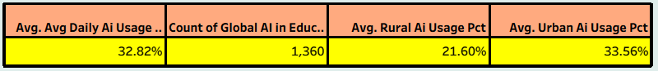

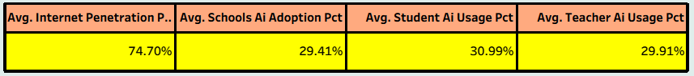

2. GEOGRAPHIC TREND IN EDUCATIONAL DEVELOPMENT
This map visualization provides a geographical view of countries in the dataset with labelled country markers. It enables users to identify the geographic distribution of data collection and understand which regions are represented in the analysis. The map shows the locations of the 10 countries: United States, Canada, Brazil, United Kingdom, Germany, Nigeria, Pakistan, India, China, and Australia. This geographical perspective helps contextualize regional differences in AI adoption patterns.

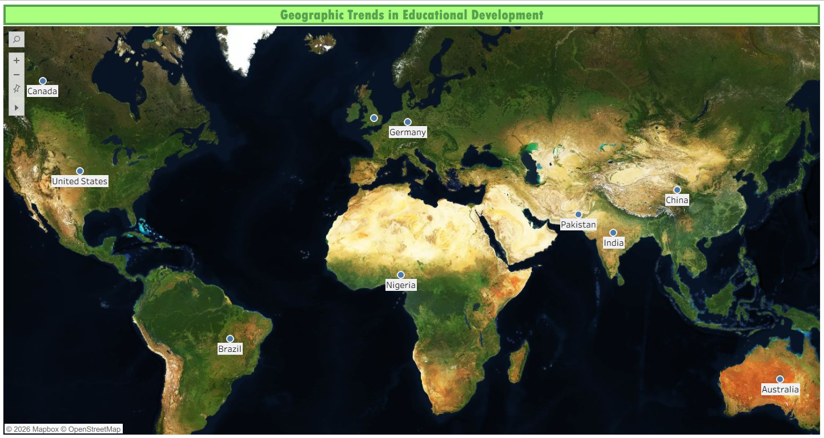

3. COUNTRY-LEVEL AI ADOPTION IN DAILY PRACTICE
This bar chart displays the average daily AI usage in minutes for each of the 10 countries in the dataset. Countries are arranged showing variations in daily usage patterns, ranging from approximately 32 to 34 minutes across most countries. This visualization helps users understand which countries have higher or lower engagement with AI tools in daily educational activities, and identify countries with similar adoption intensities. The chart reveals relatively consistent daily usage across the 10 countries, suggesting uniform engagement despite differences in overall adoption percentages.

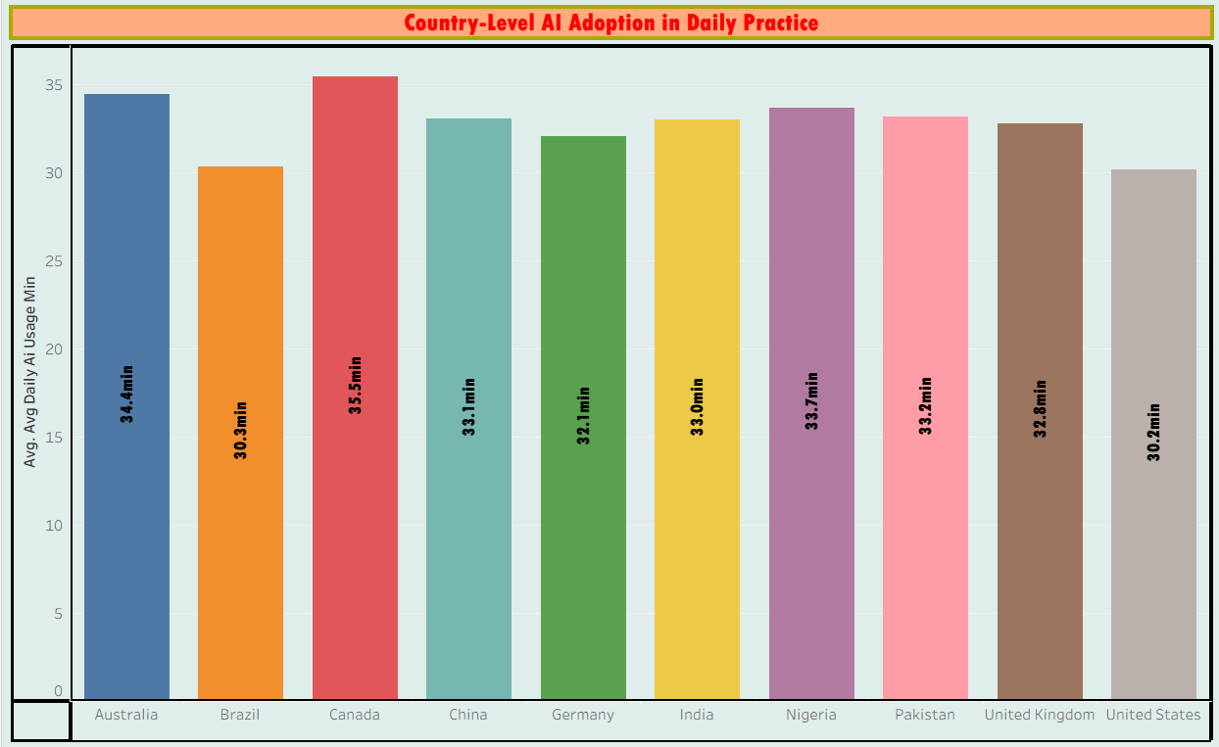

4. GLOBAL COMPARISON OF TEACHER AND STUDENT AI USAGE
This grouped bar chart compares student AI usage percentage versus teacher AI usage percentage across the 10 countries. Each country has two bars representing student usage and teacher usage rates, allowing for direct comparison of adoption patterns between these two key user groups. The visualization reveals that student and teacher adoption rates are relatively balanced across most countries, with slight variations indicating whether students or teachers are leading adoption in specific regions. This comparative view is essential for understanding stakeholder engagement and identifying countries where professional development might be needed.

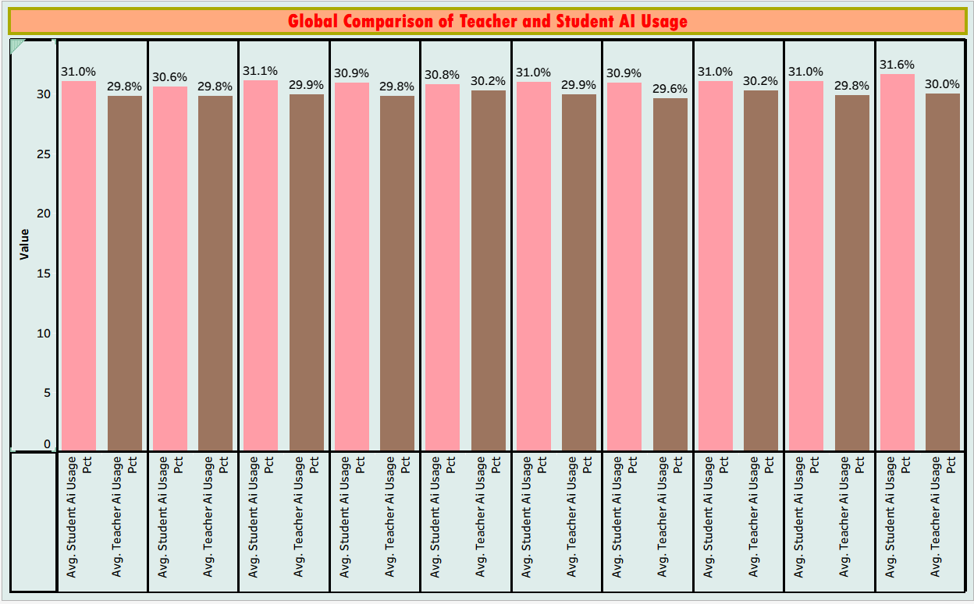

5. AI ADOPTION JOURNEY IN EDUCATION (2014-2026)
This area/trend line chart shows the growth trajectory of AI adoption percentage in schools from 2015 through 2026, spanning the entire 12-year period in the dataset. The visualization displays how school-level AI adoption has evolved over time, starting from low percentages in 2015 and potentially showing acceleration or plateau trends as time progresses. This temporal perspective is crucial for understanding the maturity of AI adoption in education and identifying periods of rapid growth or consolidation. The multi-line or area format allows users to see the overall trend while also potentially showing variation across different adoption categories or implementations.

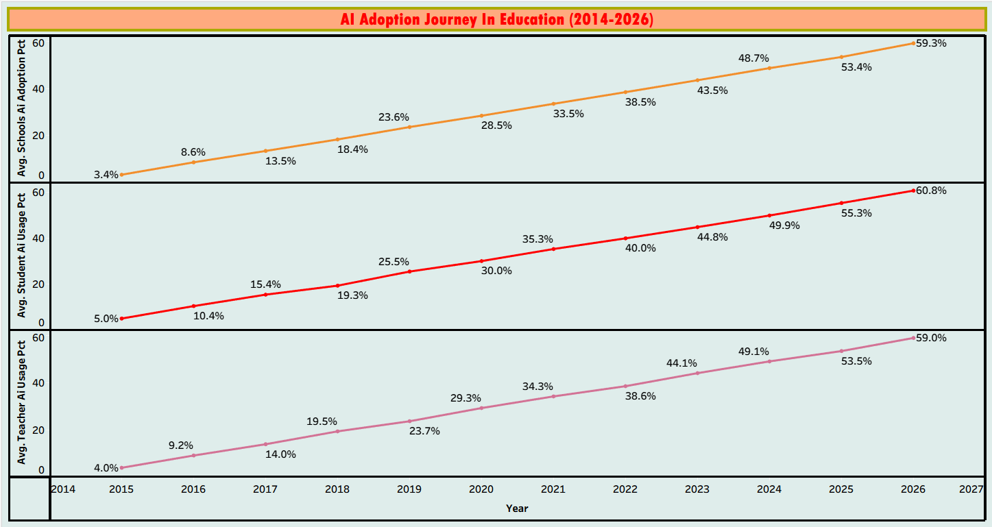
6. COMPARISON OF LEADING AI TOOLS
This pie chart displays the market share distribution of the four major AI tools used in education: ChatGPT, Google Gemini, Microsoft Copilot, and Khanmigo. The chart shows the relative adoption of each platform across the dataset, revealing which AI tools are most prevalently used in educational settings. The visualization demonstrates market competition and relative adoption success of different tools. With ChatGPT appearing to lead at 26.7%, followed by Microsoft Copilot at 25.1%, Google Gemini at 24.3%, and Khanmigo at 24.0%, the market shows relatively balanced competition with no dominant player having overwhelming market share.

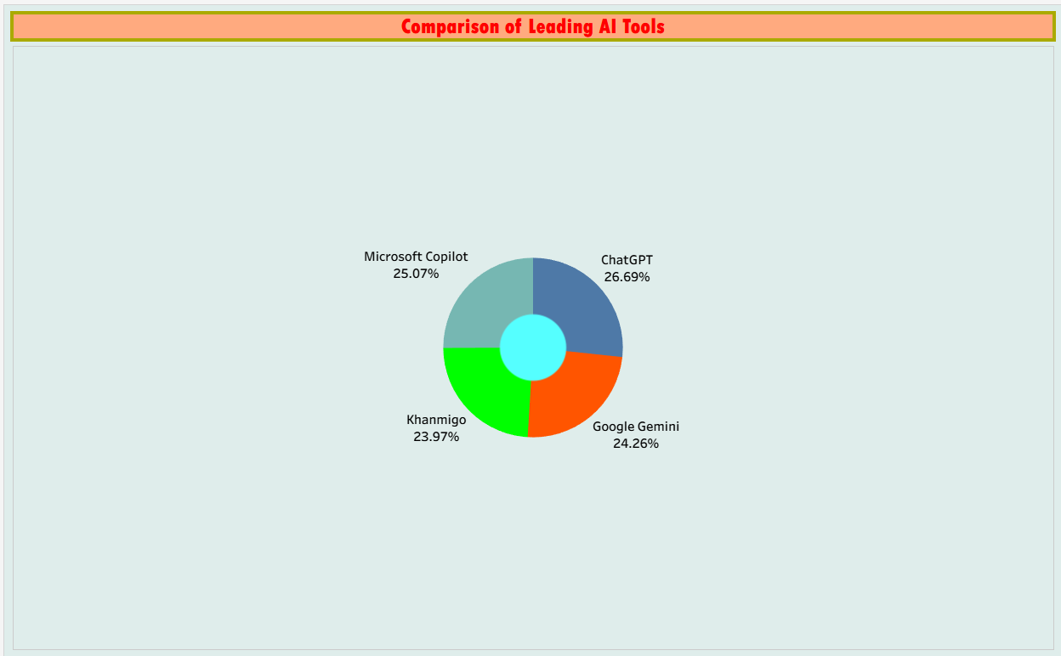

7. GROWTH OF AI USAGE ACROSS RURAL AND URBAN COMMUNITIES
This waterfall or cascade chart displays the growth trajectory of AI usage in both rural and urban communities from 2015 through 2026. The visualization shows how rural and urban adoption have evolved differently over the 12-year period. Urban areas, with better infrastructure and internet penetration, likely show higher absolute adoption rates and possibly earlier adoption timelines. Rural areas show lower initial adoption but may demonstrate faster growth rates as infrastructure improves. This comparison is crucial for identifying digital equity issues and understanding whether the urban-rural adoption gap is widening or narrowing over time.

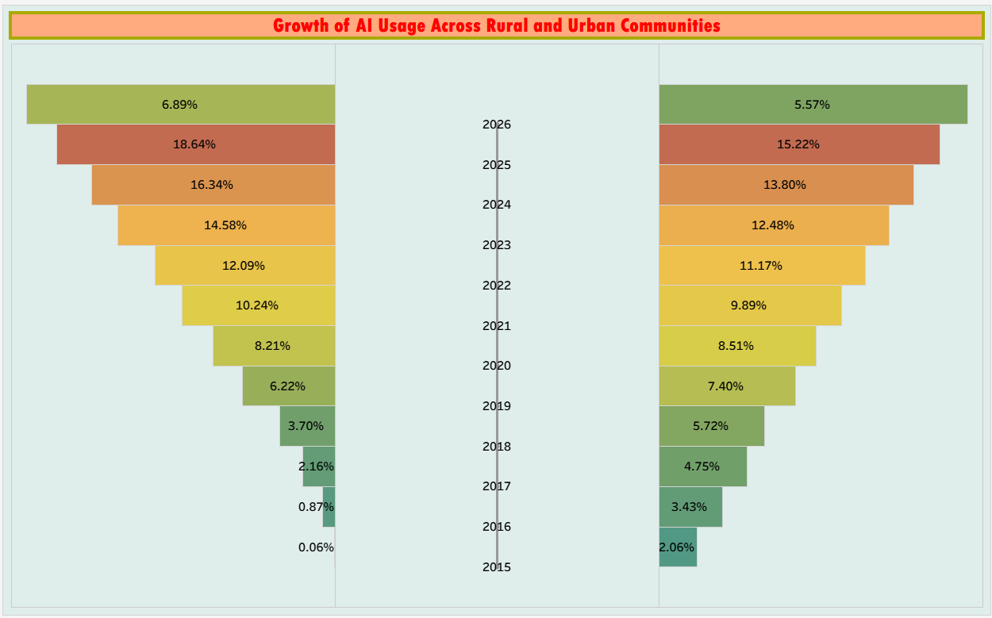

8. COMPARATIVE VIEW : SCHOOL AI ADOPTION ACROSS REGION
This donut chart compares school AI adoption percentages across the 6 global regions represented in the dataset. Each region segment represents the average school AI adoption level within that region. The chart allows users to identify which regions are leaders in educational AI adoption and which regions are lagging. The regional comparison provides strategic insights for educational policymakers and technology vendors focusing on specific markets. The visualization reveals whether adoption is concentrated in specific regions or more evenly distributed globally.

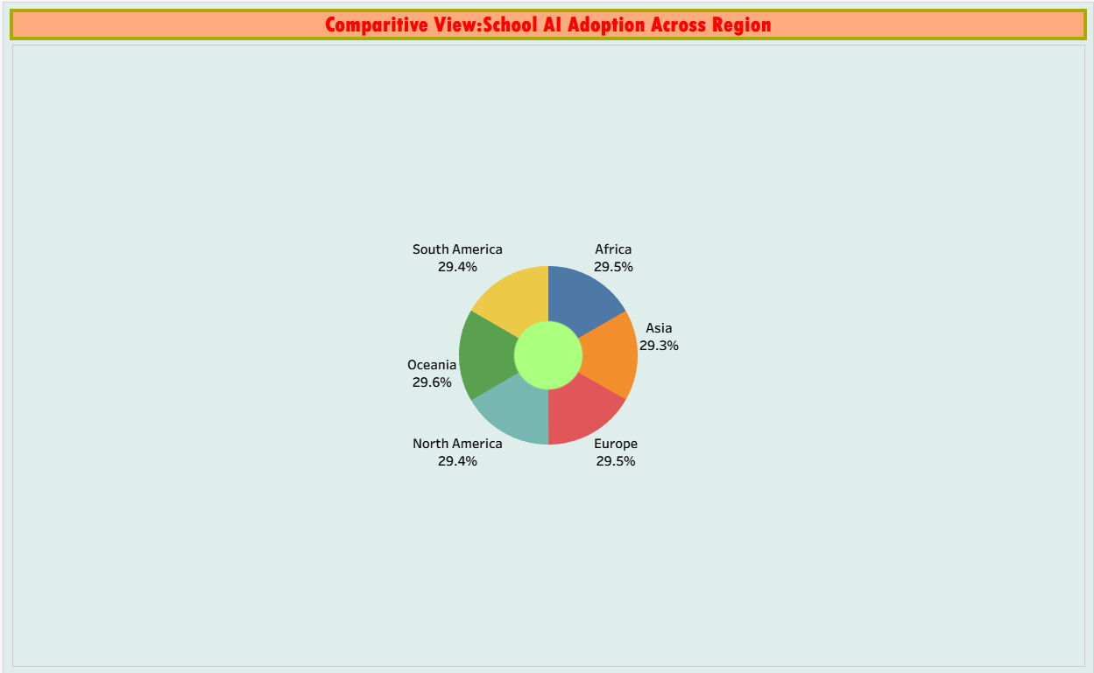

9. AI ADOPTION LEVEL BREAKDOWN BY CATEGORY
This categorical breakdown visualization displays the distribution of schools across different AI adoption levels: High Adoption (680 schools), Moderate Adoption (473 schools), and Low Adoption (207 schools). The categorization provides a segmentation of schools based on their adoption intensity, useful for identifying target markets and understanding where the majority of educational institutions currently stand in their AI adoption journey. The visualization demonstrates that schools are distributed across the adoption spectrum, with concentration in higher adoption categories indicating overall market maturation. This segmentation enables stakeholders to tailor strategies to specific adoption levels.

